**Covid-19 Impact**

Questions and Queries from Country wise latest csv file

Question 1: Top 10 most affected countries by COVID-19.

**Query:**

SELECT  
 country,   
 SUM(confirmed) as CONFIRMED

FROM   
 country_wise_update

GROUP BY   
 country

ORDER BY 2 DESC

LIMIT 10;

**Result :**

Question 2: Weekly % Increase in Cases

**Query:**

SELECT   
 country,  
 SUM(per_week_percent_increase) as per_week_increase

FROM   
 country_wise_update

GROUP BY   
 country

ORDER BY 2 DESC

LIMIT 10;

**Result:**

Question 3 : Which countries have the highest mortality rates and their recovery rates?

**Query:**

SELECT

Country,

(Deaths * 100/ Confirmed ) AS MortalityRate,

(Recovered * 100/ Confirmed) AS RecoveryRate

FROM

country_wise_update

ORDER BY

MortalityRate DESC

LIMIT 10;

**Result :**

Question 4 : How do new cases and deaths differ across WHO regions?

**Query:**

SELECT

WHO_Region,

SUM(New_cases) AS TotalNewCases,

SUM(New_deaths) AS TotalNewDeaths

FROM

country_wise_update

GROUP BY

WHO_Region

ORDER BY

TotalNewCases DESC;

Result:

Questions and Queries from Covid 19 clean complete csv file

Question 1 : What is the trend of cases in a specific country (e.g., "Australia") over time?

**Query:**

SELECT

Date,

SUM(Confirmed) AS Daily_Cases

FROM covid19_clean_complete

WHERE Country = 'Australia'

GROUP BY Date

ORDER BY Date DESC;

**Result:**

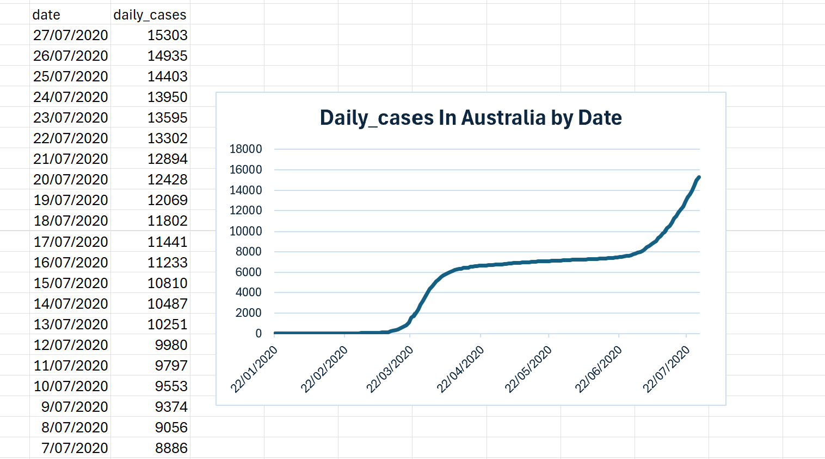

Question 2 : Which who region had the highest recovery rate?

**Query:**

SELECT

who_region,

SUM(Recovered) * 100.0 / SUM(Confirmed) AS Recovery_Rate

FROM covid19_clean_complete

GROUP BY who_region

ORDER BY Recovery_Rate DESC

**Result:   
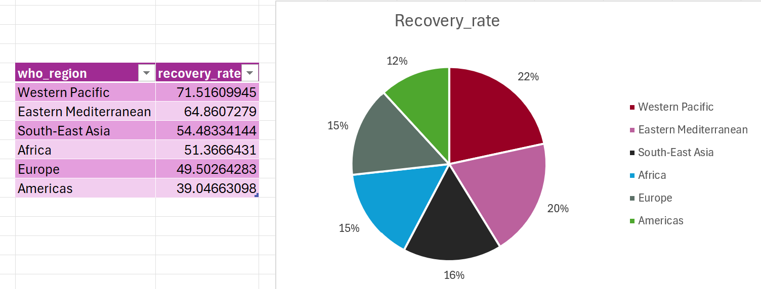**

Question 3: Identify the highest increase in cases within a day In Australia.

**Query:**

SELECT

Country,

Date,

MAX(Confirmed) - MIN(Confirmed) AS Daily_Increase

FROM covid19_clean_complete

WhERE country = 'Australia'

GROUP BY Country, Date

ORDER BY Daily_Increase DESC

LIMIT 5;

**Result :   
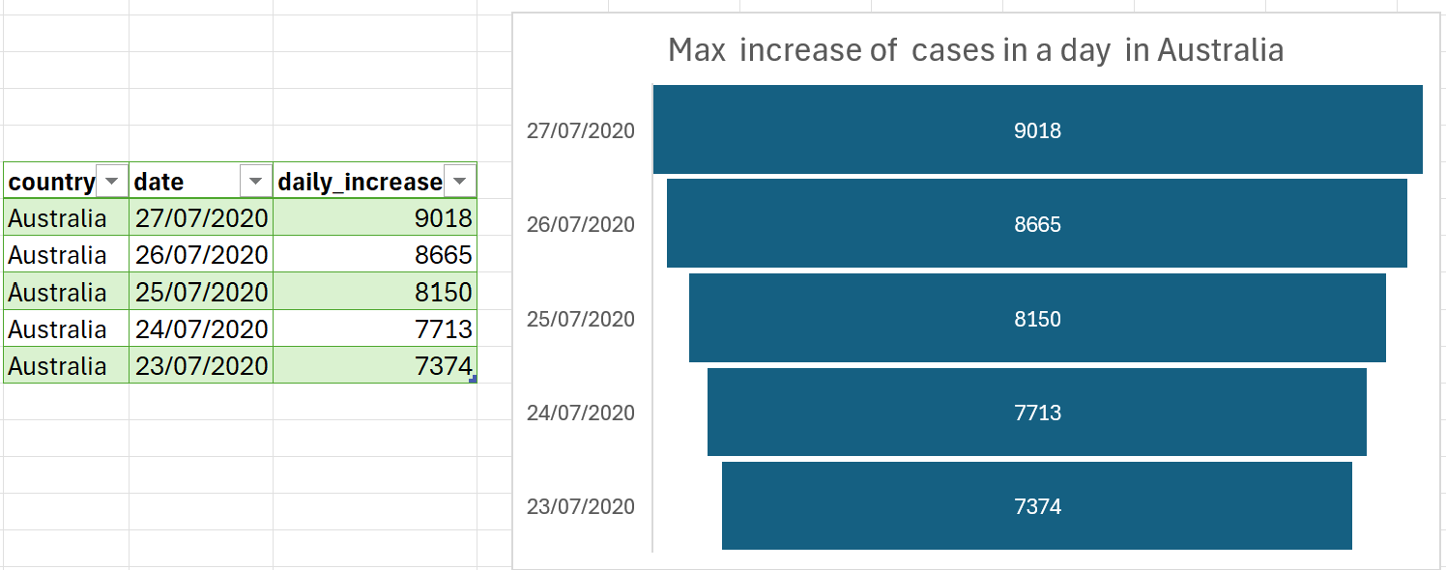**

Questions and Queries from day wise csv file

Question 1: On which dates did the world see the highest daily increase in cases and deaths?

**Query:**

SELECT

Date,

New_cases,

New_deaths

FROM

day_wise

ORDER BY

2 DESC

,3 DESC

LIMIT 1;

**Result:**

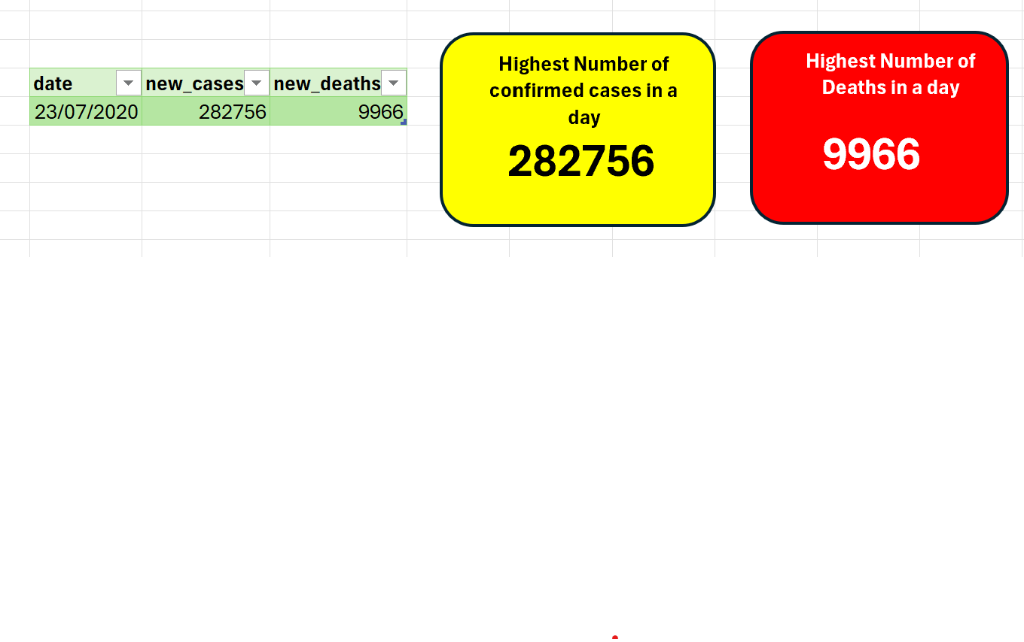

Question 2 : How does the recovery trend compare with the active case trend over time?

**Query:**

SELECT

Date,

Recovered,

Active

FROM

day_wise

ORDER BY

Date;

**Result:**

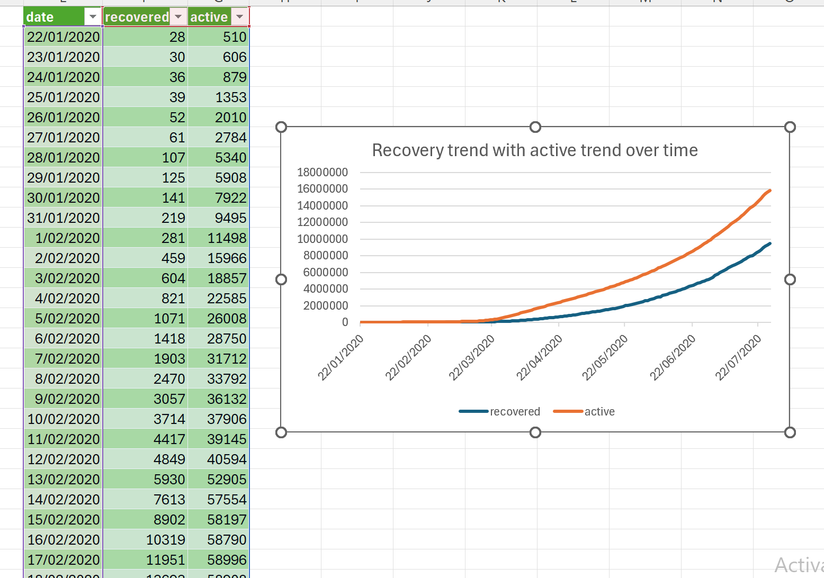

Questions and Queries from fully grouped csv file

Question 1: On which date did the world pass 1 million confirmed cases?

**Query:**

SELECT

Date,

SUM(Confirmed) AS CumulativeConfirmed

FROM

fully_group

GROUP BY

Date

HAVING

SUM(Confirmed) >= 1000000

ORDER BY

Date  
LIMIT 1;

**Result:**

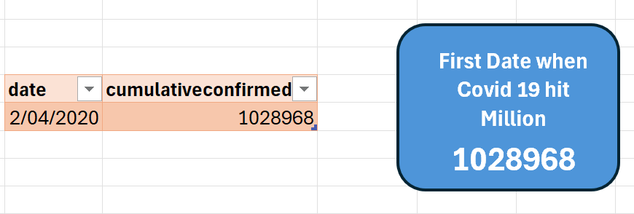

Question 2: Compare month-over-month increase in confirmed cases in Australia

**Query:**WITH MonthlyCases AS (

SELECT

Country,

DATE_TRUNC('month', Date) AS Month,

MAX(Confirmed) AS TotalConfirmed

FROM

fully_group

GROUP BY

Country, DATE_TRUNC('month', Date)

),

MonthlyGrowth AS (

SELECT

Country,

Month,

TotalConfirmed - LAG(TotalConfirmed) OVER (PARTITION BY Country ORDER BY Month) AS MonthlyIncrease

FROM

MonthlyCases

)

SELECT *

FROM MonthlyGrowth

WHERE MonthlyIncrease IS NOT NULL And country = 'Australia';

Result:   
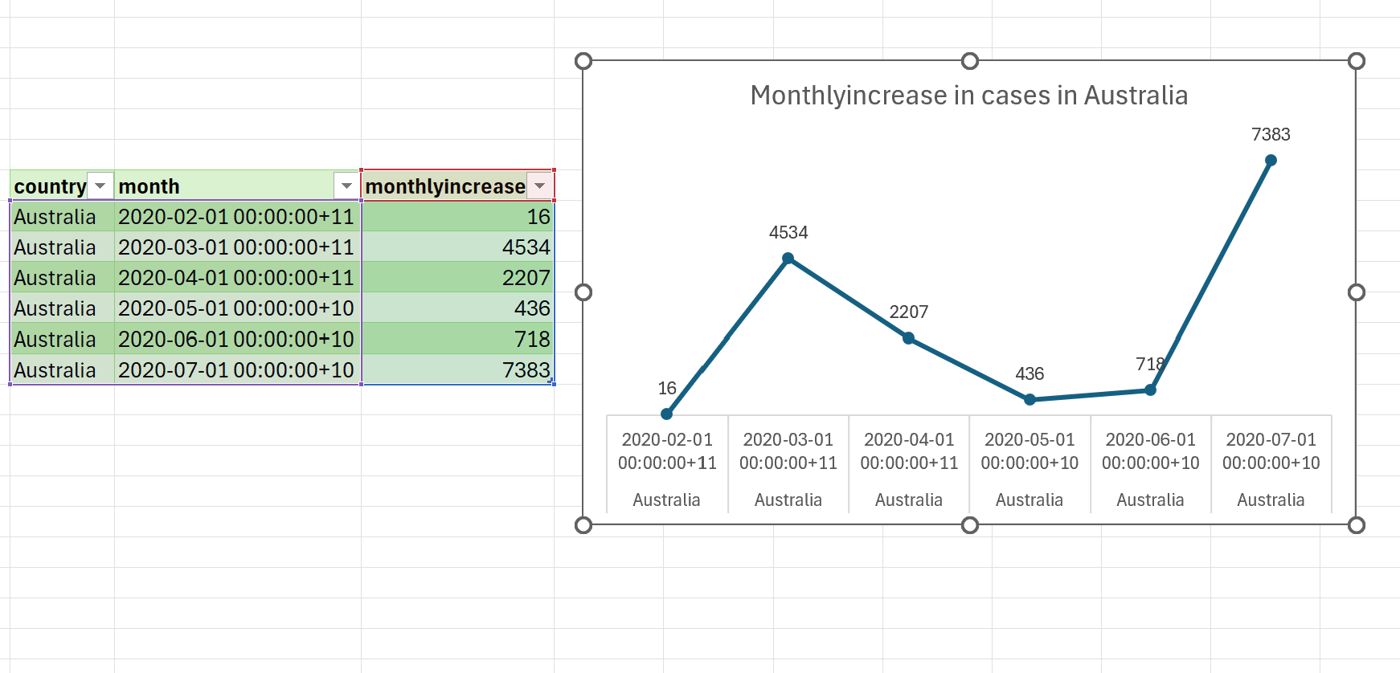

Questions and Queries from USA Country wise latest csv file

Question 1: Generate a summary view of USA daily COVID state

**Query :**SELECT

Date,

SUM(Confirmed) AS TotalConfirmed,

SUM(Deaths) AS TotalDeaths

FROM

usa_country_wise

GROUP BY

Date

ORDER BY

Date;

**Result:   
**

Question 2 : Which states had decreasing new cases for at least 7 days straight?  
**Query :**

WITH StateDaily AS (

SELECT

province_state,

Date,

SUM(Confirmed) AS TotalConfirmed

FROM

usa_country_wise

GROUP BY

province_state, Date

),

NewCases AS (

SELECT

province_state,

Date,

TotalConfirmed - LAG(TotalConfirmed) OVER (PARTITION BY province_state ORDER BY Date) AS DailyNew

FROM

StateDaily

),

Trends AS (

SELECT

province_state,

Date,

CASE

WHEN DailyNew < LAG(DailyNew) OVER (PARTITION BY province_state ORDER BY Date)

THEN 1 ELSE 0 END AS IsDecreasing

FROM

NewCases

)

SELECT

province_state, SUM(IsDecreasing)

FROM

Trends

GROUP BY

province_state

HAVING

SUM(IsDecreasing) >= 7;

**Result:**  
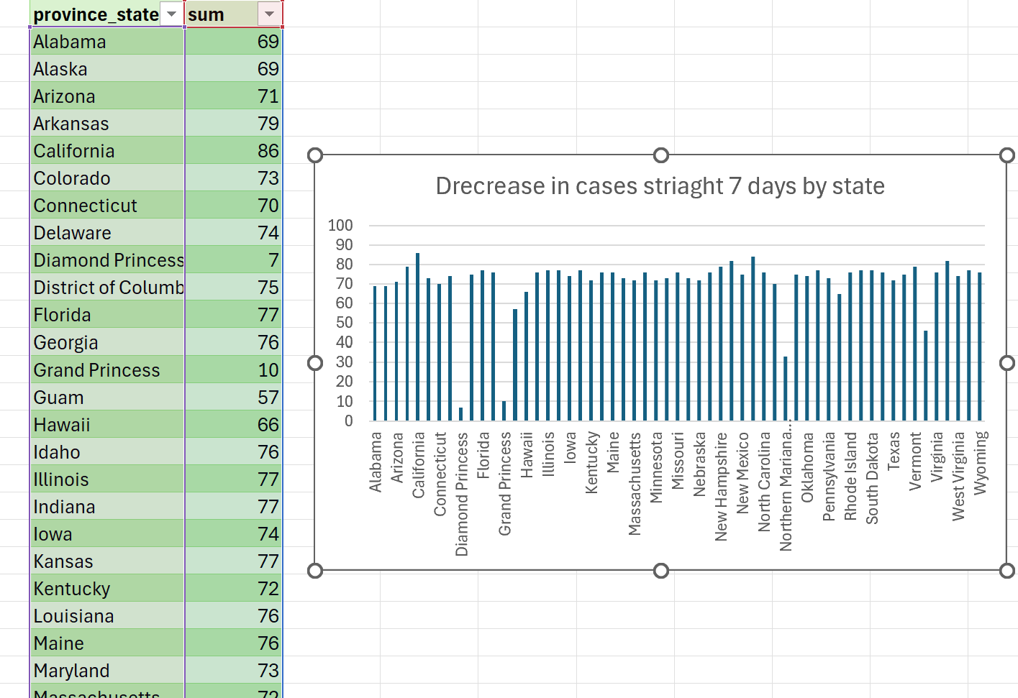

Questions and Queries from Worldometer csv file

Question 1: Which continents have the highest testing efficiency (tests per million vs. total cases)?

**Query:**

SELECT

Continent,

SUM(totaltests/testsper1M_pop) AS TotalTestsPerMillion,

SUM(TotalCases) AS TotalCases,

SUM(totaltests/testsper1M_pop) / SUM(TotalCases) AS TestsPerCase

FROM

worldometer

GROUP BY

Continent

ORDER BY

TestsPerCase DESC;

**Result:**

Question 2: Which countries have the highest proportion of critical cases relative to active cases?

**Query:**   
SELECT

Country,

(Serious_Critical * 1.0 / ActiveCases * 100) AS CriticalCasePercentage

FROM

worldometer

WHERE

ActiveCases > 1000

AND Serious_Critical IS NOT NULL

ORDER BY

CriticalCasePercentage DESC

LIMIT 10;

**Result :**  
